PAYING GUEST

(PG ACCOMODATION SYSTEM)



Submitted by

**Divya Bharti**

**1256510**

Submitted To:

**Er.Kalpna Verma Er.Asish Verma**

**(Associate Prof & HOD CSE/IT) Asst. Prof. CSE**

**Department Of Computer Science and Applications**

**Kuruskshetra University**

**INDEX**

* COMPANY PROFILE
* PYTHON INTRODUCTION
* CHARACTERSTICS
* INTRODUCTION ABOUT PROJECT
* PROJECT MODULES
* ABOUT TRAINING
* HARDWARE AND SOFTWARE TO BE USED

**COMPANY PROFILE**

**INFOWIZ** is leading strategic **IT Company** offering integrated IT solution. INFOWIZ is having rich experience managing global clients across various business verticals and align IT strategies to achieve business goals. The various accreditations that we have achieved over the years for every services, reflects our commitment towards the Quality Assurance.

**INFOWIZ** was founded in the year 2009 with the mission to provide Industrial training to aspiring Engineers and technical support to industries. Within a short span of 11 years “Infowiz” has become one of the leading organizations which offer state of art professional IT solutions, Industrial Trainings, technical support and consultancy to software companies in India and abroad. Due to quality assurance and high level of commitments in our services, we have won quite a few accolades and are associated with reputed universities and popular corporate, in this field. We strive to impart personalized, professional and contemporary experiential trainings to all the engineering streams that are necessary for the career, success and growth for both students & industry respectively.

We believe in**“Better Skills-> Better Jobs-> Better Life”**

Keeping in mind, requirement of present time, we have established a separate training and skill development wing for students that help them in providing exposure to industry and in getting real time practical knowledge of work. We have a pool of experts in our faculty specializing in specific areas that serve organizations of numerous industries. We offer training and learning that are tailored to provide solutions to help increase productivity, performance and profitability of organizations. Our courses offer in-depth coverage of specific and focused skills. We are also committed to place our students within various companies so that they can get dream job after completion of training.

**OUR TEAM:**

Our Technical team of professionals are already designing & delivering state of the art projects to its customers. **INFOWIZ** has a strong presence in the **North India & in US**. Our engineers are already working on the latest technologies namely **iPhone & Android Applications, Robotics, VLSI-VHDL, Embedded System, Networking and Cloud computing.**

**MANAGEMENT & LEADERSHIP:**

INFOWIZ is led by a team of professionals and technicians who are experienced enriched, committed and always ready to accept contemporary challenges. The leadership think tank comprises of the young and dynamic personalities with a distinct vision of improvising quality knowledge and skill development as core competencies among the budding engineers.

**1. Mr. Kamaljot Kansal (CEO)**

Mr. Kamaljot Kansal has been turning ideas into realities ever since he has taken up the task of promoting INFOWIZ. In his own words “*I never dreamt about success I worked for It.*” reflects that he believes in talk less and work more theory. No doubt under his leadership INFOWIZ has become one of strongest companies in the field of IT solutions in less than a decade. His management fundamental is “team work” as he takes along, talks along all his team members and appreciates and attributes their contribution to the success of INFOWIZ. He is determined to uplift Infowiz among the top 5 companies in the country.

**2. Dr. Seema (Managing Director)**

Dr. Seema has with more than 11 years of practical experience in the field is one of the strongest pillars of INFOWIZ. Her management style is unique and well accepted by the students and associates. She believes in taking new challenges and implementing rational strategies for the benefit of organization.

**RECOGNITION:**

Organization registered under Government of India

ISO 9001:2015 Certified

Member of Confedration of Indian Industries.

Three Times National Award Winning Organisation.



**ISO9001:2015  
(International Standardization Organisation)**

Being registered under the Govt. of India, Infowiz has ISO Certification too (ISO 9001:2015) which implies that the courses undertaken at Infowiz are duly Certified and are in full compliance with the standards lay down by the Government sector making the candidate fully eligible for jobs in Government sector.



[PLACEMENTS](http://www.infowiz.co.in/placements/)**:**

Training at **INFOWIZ** is a continuous process. The entrant is shaped and attuned to the prerequisites of the professional world, right from the day one. In-house training is what the Institution emphasizes at every level, which picks up momentum by the time student reaches towards the end of his/her training.

The employability status of a student becomes the paramount concern for the company during the course of training which enhances the technical skills and soft skills of the students.

**DRDO, CEERI, Ericsson India, NTPC, MTS, Nokia Siemens, Tata Teleservices, REIL, CEG, Indian Railways, CRD Labs, GTL Ltd., Door Darshan Kendra, United Spirits and Karrox are some of the prestigious organizations where students have been placed.**

Regular sessions are held for the development of technical skills. Corporate etiquette is also floated in practice for the students to absorb the behavioural trait. These efforts are made to bridge up the gap between theory outline and application requirement so as to build up a congenial Industry-Institution Interface.

### Clients We’ve Worked with So Far

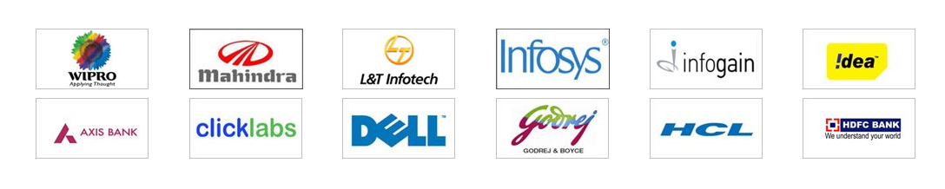

**FRANCHISE:**

**Infowiz** offering Industrial Training Franchise Opportunity in every district & states of India. **Infowiz** is a well known brand for Industrial training program in Technical Education. Presently **Infowiz** is running its Institutes in **Mohali/Chandigarh, Bathinda** and coming up with more Industrial training institutes in PAN India.

## Our Work

We work in PHP, .NET, Java, IOS, Android apps, Word Press, Joomla, Bootstrap, Civil and Mechanical Softwares.

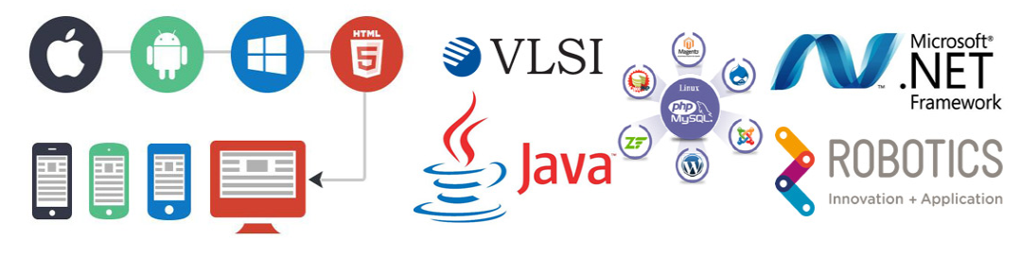

**Chandigarh Branch: Phone:**

SCO 118-120, (Near State Bank Of India), +91 172-4567-888

Sub City Center, Sector 34-A, Chandigarh, +91 9888-500-888

Pin Code 160022. +91 9888-600-888

**Bathinda Branch: Phone:**

First floor, Crown Tower, 100 +91 164-5007-088

Feet Road, Bathinda, +91 9023-500-888

Pin Code 151001. +91 9023-600-88

**WEB SITE:** [info@infowiz.co.in](mailto:info@infowiz.co.in), [www.infowiz.co.in](http://infowiz.co.in/)

**ROADMAP OF FUTURE:**

***INFOWIZ’s*** future plans include regional and national expansion through both COCO and FOFO business models. Our 1st COCO branch is already operational at Bathinda. Being an ISO certified company and member of CII we have attained very high level of accomplishments in the Industrial training business that we want to take to masses. Infowiz is committed to develop its strengths & core competencies with continuous research & technical excellence. It would never cease to embrace and add latest technological advancements in the field of trainings and pass the same to the students as and when demand will arise, creating the best and most modern atmosphere for learning.

**Chandigarh Branch Road Map:**

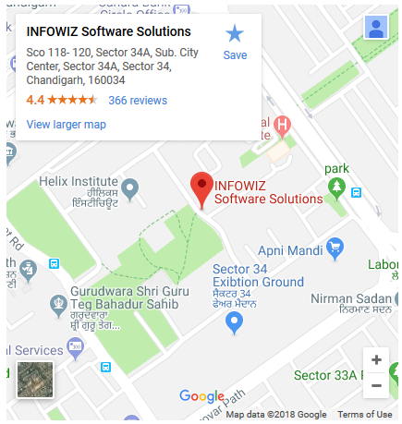

**What is Python?**

Python is a popular programming language. It was created in 1991 by Guido van Rossum.

It is used for:

* web development (server-side),
* software development,
* mathematics,
* system scripting.

**What can Python do?**

* Python can be used on a server to create web applications.
* Python can be used alongside software to create workflows.
* Python can connect to database systems. It can also read and modify files.
* Python can be used to handle big data and perform complex mathematics.
* Python can be used for rapid prototyping, or for production-ready software development.

**Why Python?**

* Python works on different platforms (Windows, Mac, Linux, Raspberry Pi, etc).
* Python has a simple syntax similar to the English language.
* Python has syntax that allows developers to write programs with fewer lines than some other programming languages.
* Python runs on an interpreter system, meaning that code can be executed as soon as it is written. This means that prototyping can be very quick.
* Python can be treated in a procedural way, an object-orientated way or a functional way.

**Python Features**

Python provides lots of features that are listed below.

***1) Easy to Learn and Use***

Python is easy to learn and use. It is developer-friendly and high level programming language.

***2) Expressive Language***

Python language is more expressive means that it is more understandable and readable.

***3) Interpreted Language***

Python is an interpreted language i.e. interpreter executes the code line by line at a time. This makes debugging easy and thus suitable for beginners.

***4) Cross-platform Language***

Python can run equally on different platforms such as Windows, Linux, Unix and Macintosh etc. So, we can say that Python is a portable language.

***5) Free and Open Source***

Python language is freely available at [offical web address](https://www.python.org/).The source-code is also available. Therefore it is open source.

***6) Object-Oriented Language***

Python supports object oriented language and concepts of classes and objects come into existence.

***7) Extensible***

It implies that other languages such as C/C++ can be used to compile the code and thus it can be used further in our python code.

***8) Large Standard Library***

Python has a large and broad library and prvides rich set of module and functions for rapid application development.

***9) GUI Programming Support***

Graphical user interfaces can be developed using Python.

***10) Integrated***

It can be easily integrated with languages like C, C++, JAVA etc.

**ABOUT TRAINING:**

* **HTML**
* **CSS**
* **JAVASCRIPT**
* **JQUERY**
* **MYSQL**
* **BOOTSTARP**
* **PYTHON**

**HARDWARE AND SOFTWARE REQUIREMENTS:**

* **HARDWARE REQUIREMENTS:**
* Pentium-IV (Processor).
* 256 MB Ram
* 512 KB Cache Memory
* Hard disk 10 GB
* Microsoft Compatible 101 or more Key Board
* **SOFTWARE REQUIREMENTS:**
* **Operating System :** Windows
* **Programming language:** PYTHON
* **Front-End:** HTML,CSS, J-query, Java script ,Django
* **Back-End: SQL**LITE
* **Web Server:** PYTHON Server 3.6

**PROJECT DESCRIPTION**

Paying guest accommodation

Since the house rental soars have been increasing day by day, it is becoming the big issue for the poor or middle class students to get a house on rent. Especially, house for rent is good for the big families, or small families (couples and a kid). But for students, it is not at all a good idea to stay in house. Because, students will not get enough time to study, and it becomes difficult for them to clean the house, clean bathrooms and toilets, etc. Hence, being a student, it’s really a better idea to go with Paying Guest accommodation. If you are looking for houses in the city of Mumbai, just drop your idea, as cost of the house rent seems to be high.

Why to Choose Paying Guest Accommodation?

There are several reasons to choose Paying Guest accommodations. One of the best reasons is that, you will be safe from terrorists, especially if you’re a girl. Secondly, you can save lots of time for your studies, as food will be provided in the PG for at least 2 to 3 times. So there is absolutely no need to worry at all. You will get ready bed, clean bed sheets, and blankets, etc. You’ll get good support from the PG owners or your PG mates if you get lost somewhere, your Tiffin box will be filled by the cook, and you can taste different sorts of food. Moreover, PG becomes helpful for you to mingle with different types of people, know their lifestyle, and learn their lifestyle. Your PG mates become the best companion for you, if you want to move outside. You can simply enjoy a lot with them. However, you need to find the best PG in Mumbai, as not all but only few PGs are great. Which Paying Guest Accommodation is better? There are many Paying Guest accommodations in Mumbai, out of which you can choose Andhra pg in Mumbai. As Andhra people are good at cooking, you’ll be able to get.

excellent food for at least twice or thrice a day for about 6 days a week. This will assist you to stay with comfort as you will get homely food. You need to search for the standard PG with the nearest location first – it should be near to your college or institution. Also, it must be near to the hotels or street food, shopping centres, and so on. You must also be able to find auto-rickshaws, buses, taxis, etc., nearby. Besides this, banks and ATMs are a must; So that, you can withdraw amount whenever required. Do not hurry in finding the pgs, just take your own time and find out the best Andhra PG in Mumbai. It will help you to stay in home away from home. But you need to enquire about the PG owners, regarding all the facilities provided in the PGs

There is no restriction for staying – either boy or a girl can stay in PG. Hence, there are separate PGs available for boys and girls. Even there are PGs which accommodates both boys and girls. It depends upon the individuals to choose the type of PG accommodation that is required.

**MODULES:**

1. **Login Module:**

Tenants can enter into the website by logging into the website. It contains two modules for login. For login, registration is done by the tenants and login id and password are provided to the user.

1. **Add details :**

User can add details by filling into registration form. User can upload the image.

1. **Choose problem:**

User can choose problem according to their system and can find solution.

1. **Updated account information:**

User can update or change the user account details like as change the user name, change the password, change the email address.

1. **Delete User:**

We can delete the user detail or delete the user by going in to the registration table.

**REFERENCE**

* [www.w HYPERLINK "http://www.w3schools.com/" HYPERLINK "http://www.w3schools.com/" HYPERLINK "http://www.w3schools.com/"3 HYPERLINK "http://www.w3schools.com/" HYPERLINK HYPERLINK "http://www.w3schools.com/""http://www.w3schools.com/" HYPERLINK "http://www.w3schools.com/"schools.com](http://www.w3schools.com/)
* [www.phpbuddy.com](http://www.phpbuddy.com/)
* [www.mysql.com](http://www.mysql.com/)
* [www.phpeasystep.com](http://www.phpeasystep.com/)
* [www.infoq.com](http://www.infoq.com/)